W**EEKLY PROGRESS REPORT**

BY ANURAG SINGH

MUSIC PLAYER APP

* DATE:7/7/23
* PROJECT OVERVIEW:

The goal of this project is to develop a music player app for android that allows users to play audio files, create playlists, manage their music library, and provide a smooth and intuitive user experience.

* Accomplishments this Week:

1. Understanding the project objectives.
2. Understanding the app's core features and functionality, including audio playback, playlist creation, and library management.
3. Set up the development environment, installing [ ANDROID STUDIO , JAVA DEVELOPMENT KIT & SOFTWARE DEVELOPENT KIT].
4. Set up of the AVD ( Android Virtual Device) along with its software eg.Orea 8.0.0.
5. Performing the layout operation (Constarined layout) to build the interface of the app including setting up the text view and the buttons .
6. In coding part setting up the DEXTER library in the activity main file and grade build file through which library management of audio files can be done .

* Installation of the SDK:

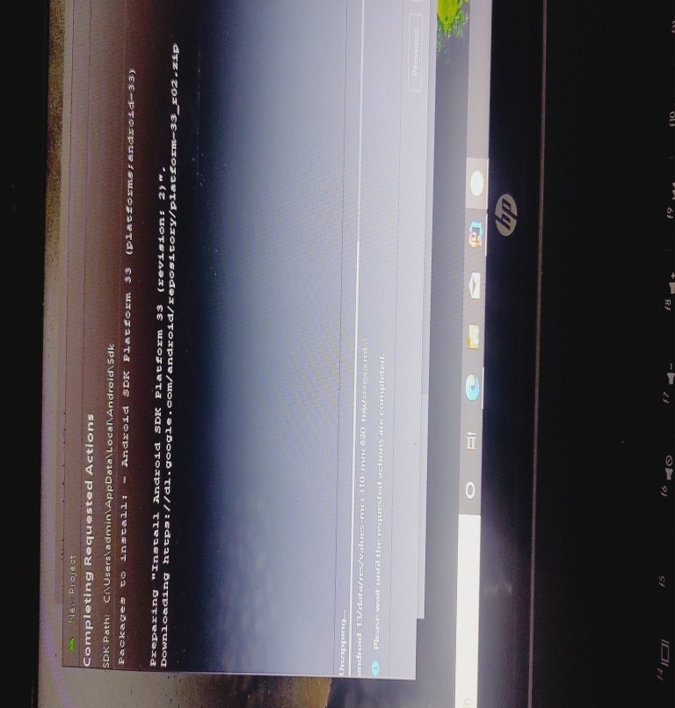

* **Setting up the AVD and installing Music Player in VD**

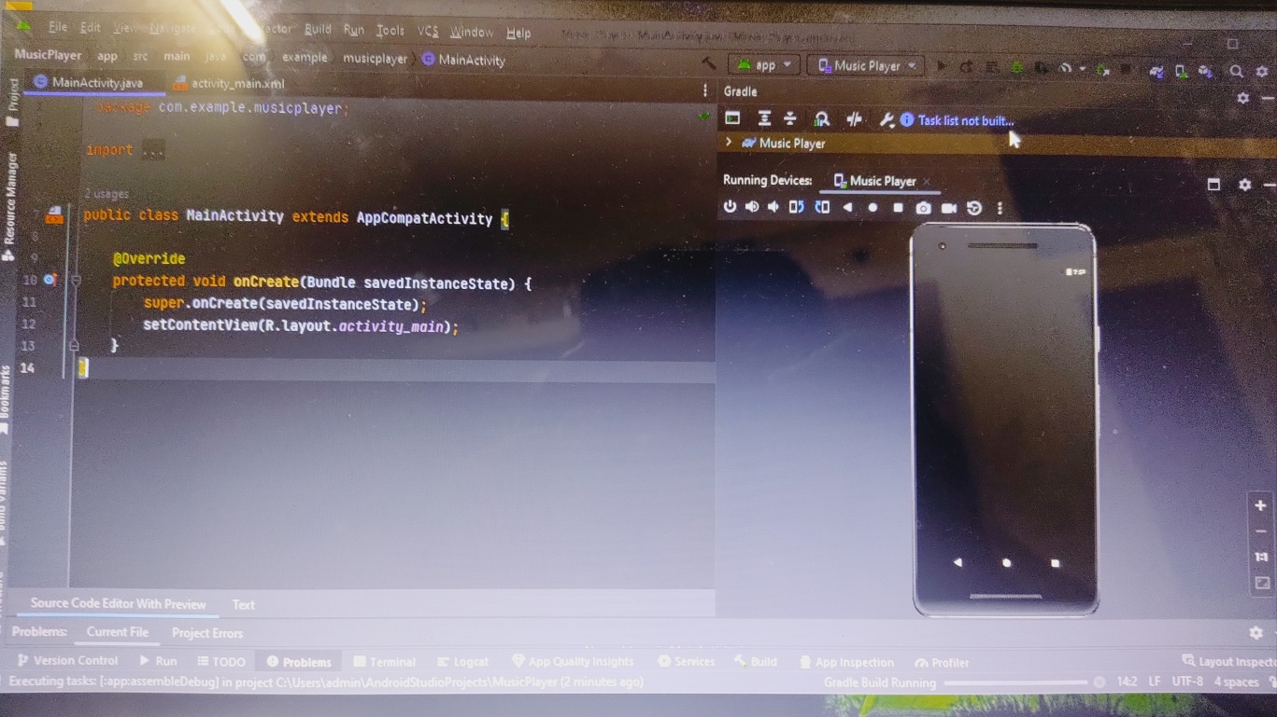

* **Importing DEXTER library for the management of audio files.**

D 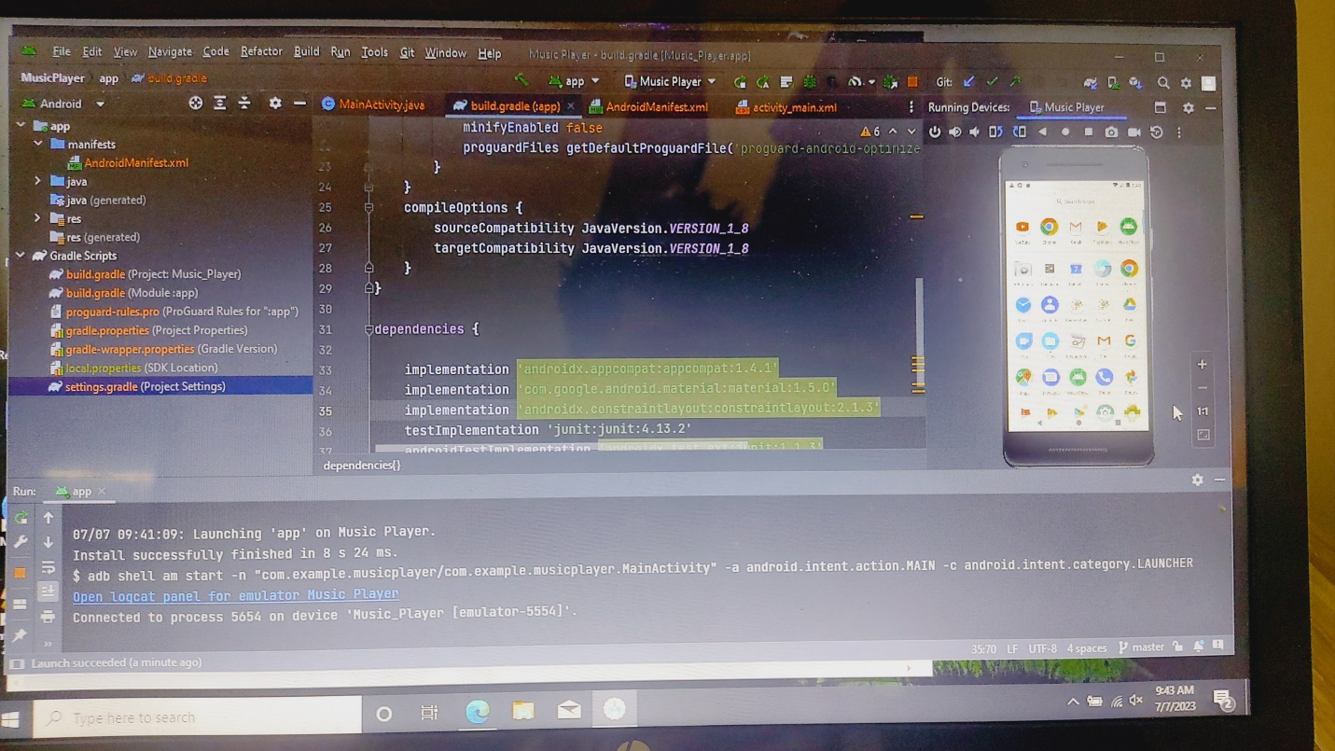

* **Challenges Faced:**

1. Faced while installation of SDK version and grade build configuration.
2. Firstly I added Physical device for the debugging and installation of the apk and then shifted to virtual device due many connection problems.

* **Next Week Objective:**

Implementing the coding part of the application at the back end and improve the interface appearance.